HUV 6.B 2.3.2021

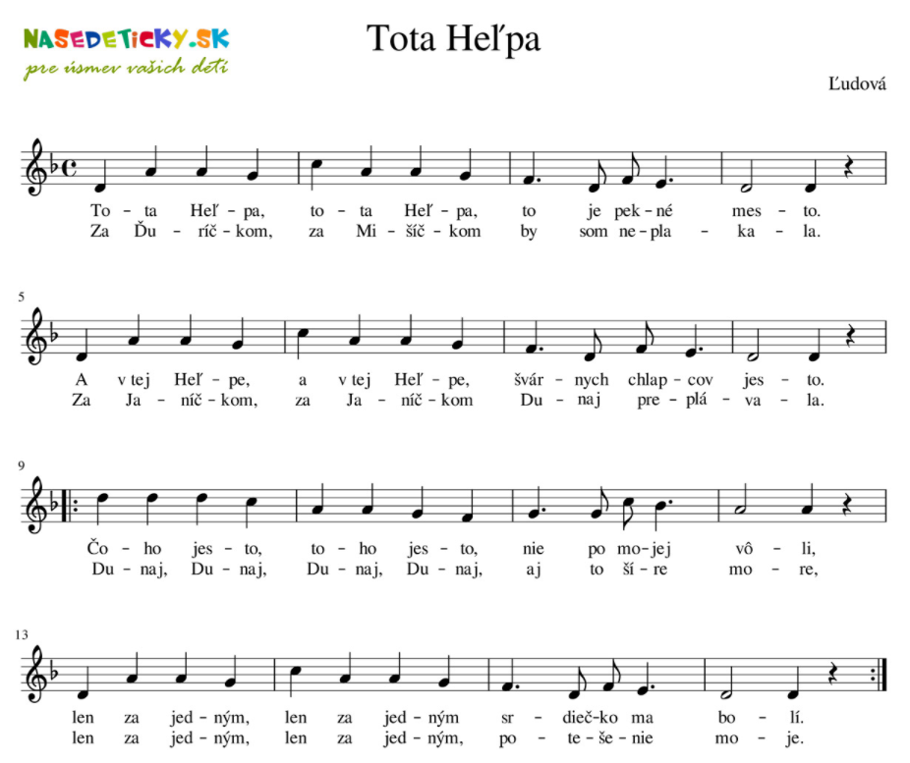

https://www.youtube.com/watch?v=6DdYz1oDzEc&ab_channel=MilanOrf%C3%A1nus

IŽ

https://pesnicky.orava.sk/noty?view=song&layout=attachment&id=14544&attachment_id=14187

https://www.youtube.com/watch?v=dvz523afay8&ab_channel=FBMChannel

