HUV 6.A 10.2.2021

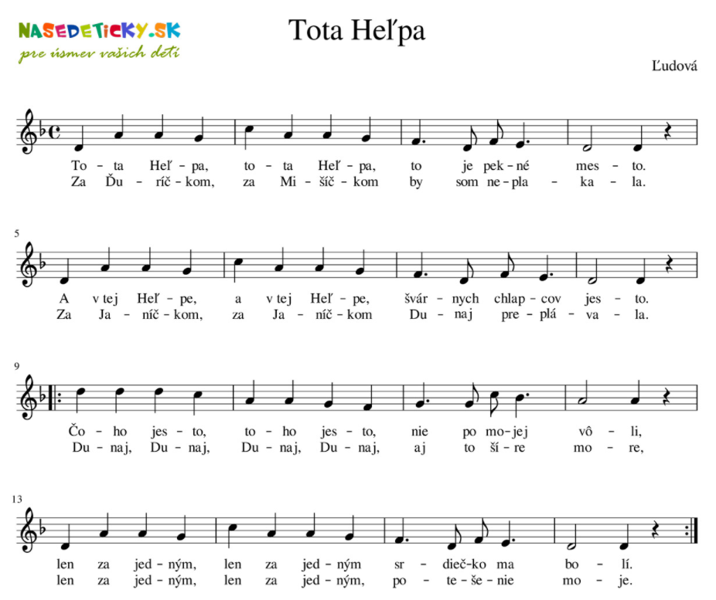

https://www.youtube.com/watch?v=6DdYz1oDzEc&ab_channel=MilanOrf%C3%A1nus

